Media Contact:

Mike King, Ohio Pork Council

[mking@ohiopork.org](mailto:mking@ohiopork.org)

**26th Annual Pork Rib-Off Attracts Ohio BBQ Competitors**

***Fairgoers Sample and Judge Pork at Ohio State Fair***

**COLUMBUS** –The Ohio Pork Council (OPC) held its 26th annual Pork Rib-Off competition on July 30 at the Ohio State Fair to the delight of scores of fairgoers who got to sample the award-winning pork while voting for their favorite.

Participants from around Ohio, including many long-time competitors, sought awards in categories for ribs, pulled pork, people’s choice, and barbecue sauce. Ale Yeah BBQ, Delaware, Ohio, was this year’s big winner, taking double top honors of Grand Champion Pork Ribs and Grand Champion Pulled Pork.

Reserve champion bragging rights went to Bark Brothers BBQ of Cincinnati for pulled pork and Baney-Q of Columbus for ribs.

Columbus-based Baney-Q also took first place honors for best BBQ sauce and won the coveted People’s Choice award for most flavorful pork.

“It’s always a great time being at Ohio Pork Council’s Rib-off, regardless of the outcome, but winning in multiple categories today was certainly a high for us,” said Cathy Baney. “We’ve been coming to this event for 10 years and we love it.”

A group of seasoned judges scored the competitors’ entries, including Representative Bob Peterson; Representative Don Jones; Adam Heffron, Executive Director, Ohio Expo Center & State Fair; Jeff Reese, Marketing Specialist, Ohio Ag Net; and Tony Dowdy, Area Director of Retail Operations, Giant Eagle.

“This was my first time judging this type of event and I really enjoyed it,” said Tony Dowdy of Giant Eagle. “Everyone was so engaged and having a good time eating and sampling great pork from the competitors.”

Each year, the Ohio Pork Council hosts the Rib-Off competition on the first Tuesday of the Ohio State Fair. This year, sponsorship from Giant Eagle further supported this event by providing the meat used by participants.

***About The Ohio Pork Council***

The Ohio Pork Council was established in 1968, beginning with nearly 800 pig farmers dedicated to the task of promoting their own product. Currently, OPC has approximately 2,500 members. Their mission is to serve and benefit all Ohio pork producers. To learn more about the Ohio Pork Council, visit [www.OhioPork.org](https://www.ohiopork.org/) or call 614- 882-5887.

For all related photos, please use this link: <https://spaces.hightail.com/space/Rph21X9pvR>

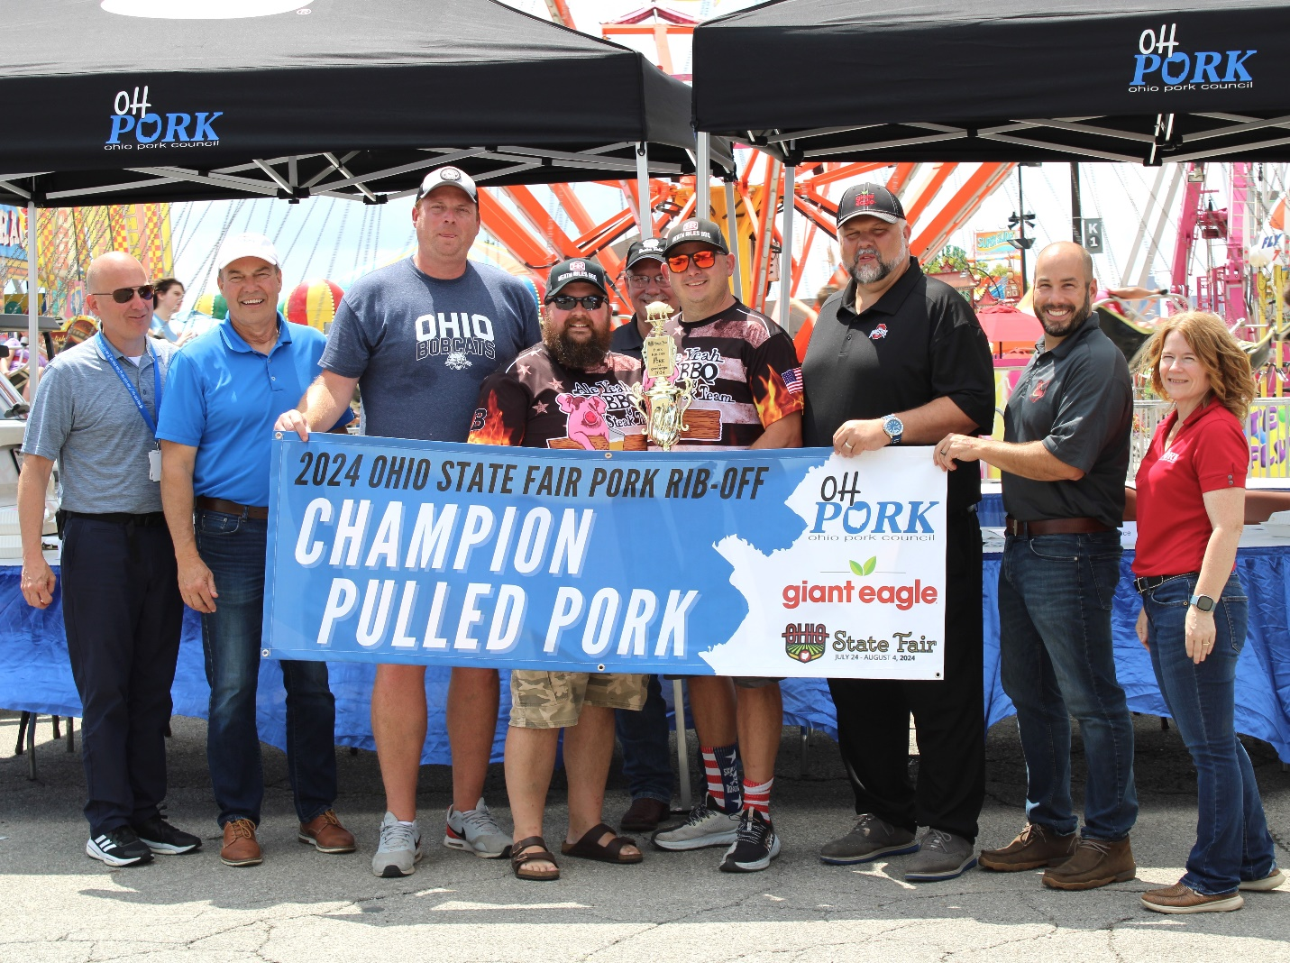

*After earning the highest votes for both rib and pulled pork this year, the team from Ale Yeah BBQ, Delaware, Ohio, (center) took top honors in both categories. Judges shown include Adam Heffron, Executive Director, Ohio Expo Center & State Fair; Rep. Bob Peterson; Representative; Tony Dowdy, Area Director of Retail Operations, Giant Eagle; and Jeff Reese, Marketing Specialist, Ohio Ag Net. Also joining was Cheryl Day, executive vice president of Ohio Pork Council.*